- Type, center, and make bold your name above this line

- Color these words (not highlight):
Red
Blue
Green

- Change font size of each line:
Make this size 12
Make this size 24
Make this size 36

- Add a page border (layout < borders < art)
- Copy this picture and paste it in front of this sentence 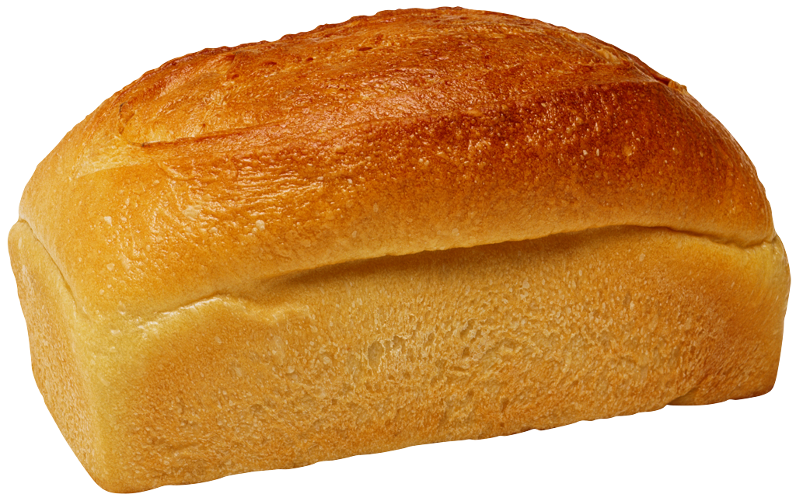

- Insert a picture below from the clipart gallery (insert < picture < clip art gallery). Resize if necessary to fit on this page.

